**Read the paragraph below; then skim and scan the advertisement and answer the following questions:**

‘App’ is a computer industry word that is short for ‘application’. It indicates the practical application of computer software that is designed to perform a specific task. A range of convenient apps is now available on mobile phones and other mobile devices around the world.

1. How many Android smartphones exist across the globe?
2. Which program has over 450000 apps available?
3. How much is the one-time registration fee for Android apps?
4. In terms of commercial developers using the App Store, what percentage are Android-based and what percentage are Apple-based?
5. Pick out one piece of information that indicates the competition between Android and Apple.
6. What percentage of 35–44 year olds played Angry Birds in the last 30 days?
7. How much would you need to pay for the Tiny Village app?
8. According to the advert, how many people use Facebook for Android? How many monthly users does that represent?

**Chapter 1**

Technology

1. According to the advert, what is the total number of people who access Facebook from their mobile phones?
2. How many full-time employees does Instagram have?
3. How much money was Instagram bought for?
4. Which company has placed this advert? What does it do?
5. Which is the email address you would use to get in touch with the advertiser?

Source: www.startapp.com/android-appsinfographic/android-apps-infographic.pdf

|  |  |  |
| --- | --- | --- |
| **Worksheet 4.2** |  | **Reading and summarizing pie charts** |

In 2011, an online language learning school conducted a survey on difficulties that people face when learning a new language. The survey was conducted using 16 000 language learners across 150 countries. The pie chart below summarises the results. Study the pie chart and then answer the questions that follow.

***What is the main difficulty that you experience when learning a new language?***

11%

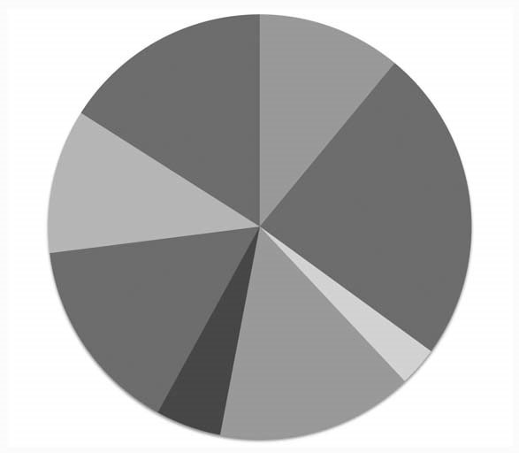

Not enough time

%

24

To keep up the

motivation

16

%

No access to

native speakers

Not enough money

11

%

To feel ashamed

when speaking a

foreign language

Bad teacher

3

%

Bad teaching method

15

%

No or limited access to

good learning material

5

%

15%

**Chapter 4**

Education

Source: https://s3.amazonaws.com/hackedu/busuu_survey.jpg

|  |
| --- |
| Of the people surveyed, 24% said ............................................................................................................  and 11 % said ...........................................................................................................................  However, another 11% said ........................................................................................................ while 5 % had .............................................................................................................................. Fifteen per cent of learners suffered from .................................................................................... and 3% were affected by ............................................................................................................... Another 15 % complained that they ................................................................................................. although 16 % admitted that they ................................................................................................ Summarize the main problems faced by people learning a new language: .............................................................................................................................................................................  ...................................................................................................................................................................  ................................................................................................................................................................... |

# 